Blur Gallery in CC2014 – the Panning Shot
Open your image in Photoshop. I’ve shown the RAW conversion settings I used for this image. NB. This was shot at f/4 and 1/800sec, so the spokes have been ‘frozen’ and rendered sharp. This doesn’t give any impression of movement, but we can soon fix that!
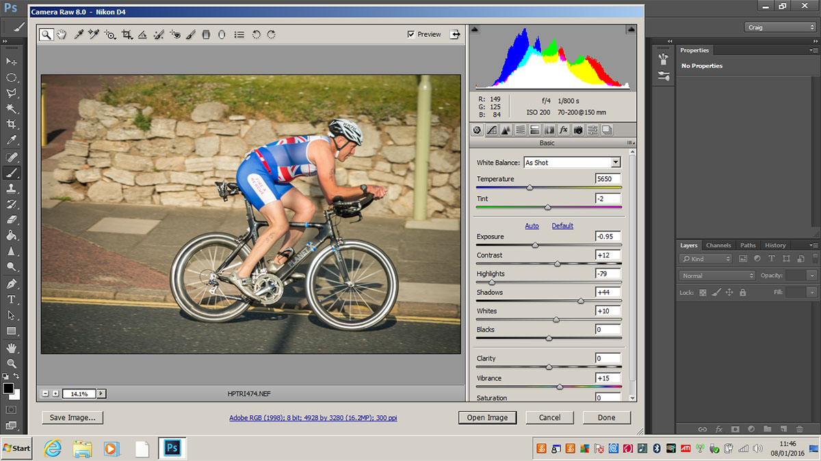
This one is a bit off-centre and needs straightening too. Select the crop tool and drag a box over the image and rotate/move the sides in to get the desired size. For this panning effect to work it is best not to crop too tight. Unfortunately this leaves a bit missing on the left. Not to worry, select the polygonal lasso tool and select the area that’s missing – remember to leave a few pixels of the original image selected otherwise Photoshop can’t work its wonders!
Edit>Fill>Content Aware and press OK. This normally does a fair job, but if it is less than perfect you can clone/heal/re-content aware fill parts to rectify.
In the olden days we would use Motion Blur to make the rider appear to be moving, but this had several limitations – the main one being the image required a fair amount of masking to make it look realistic.
Photoshop CC2014 (and CS6 onwards) uses a ‘Blur Gallery’ – a number of blur filters which can be used individually or together to give control over where, how much and even the direction of the blur in the image.
A good technique is to first convert the image to a Smart Object then we can go back into the blur gallery at any point to change the settings and also use the mask to hide some of the blur.
Right-click on the layer in the layers palette and choose Convert to Smart Object or Layer>Smart Objects>Convert to Smart Object.
Launch the Blur gallery by using Filter>Blur Gallery>Path Blur.
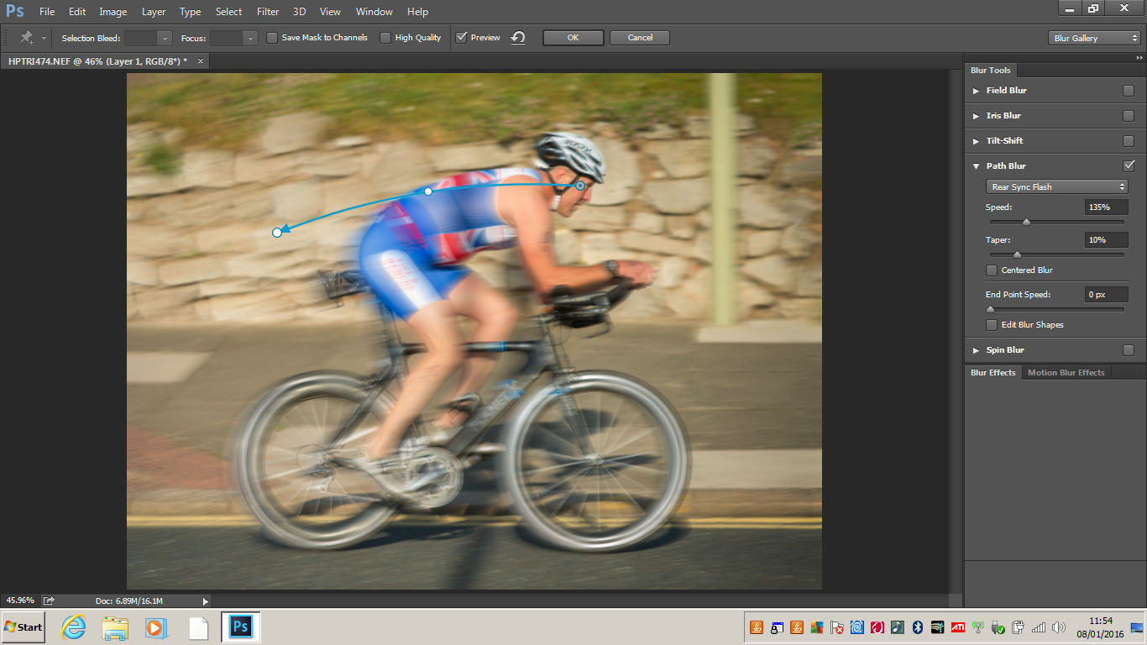
An arrow will appear in the middle of your image. It will be pointing left to right by default and this is the direction it will blur the image. Typical, I want it to go the other way!
Let’s look at the settings. The Basic Blur setting will extend the blur both ways (similar to the old motion blur) but by choosing Rear Sync Flash from the dropdown it renders the blur more directional. Adjust speed and taper (how far the blur extends beyond the edges) to the desired amount of blur on the background. Here I used 135% and 10%. I don’t want the face to be blurred, so grab the start end of the path arrow and drag it over the face. Drag the other end (arrow) to roughly straight across from this and then move the mid-point to get almost a straight line. I made the path a little bit curved in the example. Make the start point active and set End Point Speed to 0 using the slider. The face should become sharp. NB. Use Cntl+drag to move the whole arrow at one time.
Click OK and the filter will do its thing (Eventually! Be careful - this filter can take a long time on larger images.). Use the mask to paint out any part where you want to reduce the blur. I removed some of the blur by painting at about 30% opacity on the front edges of the image, the writing on the helmet and vest and the bike frame. Alt+click on the mask icon in the layers palette will show where you have painted. Alt+click again to get back to the image.
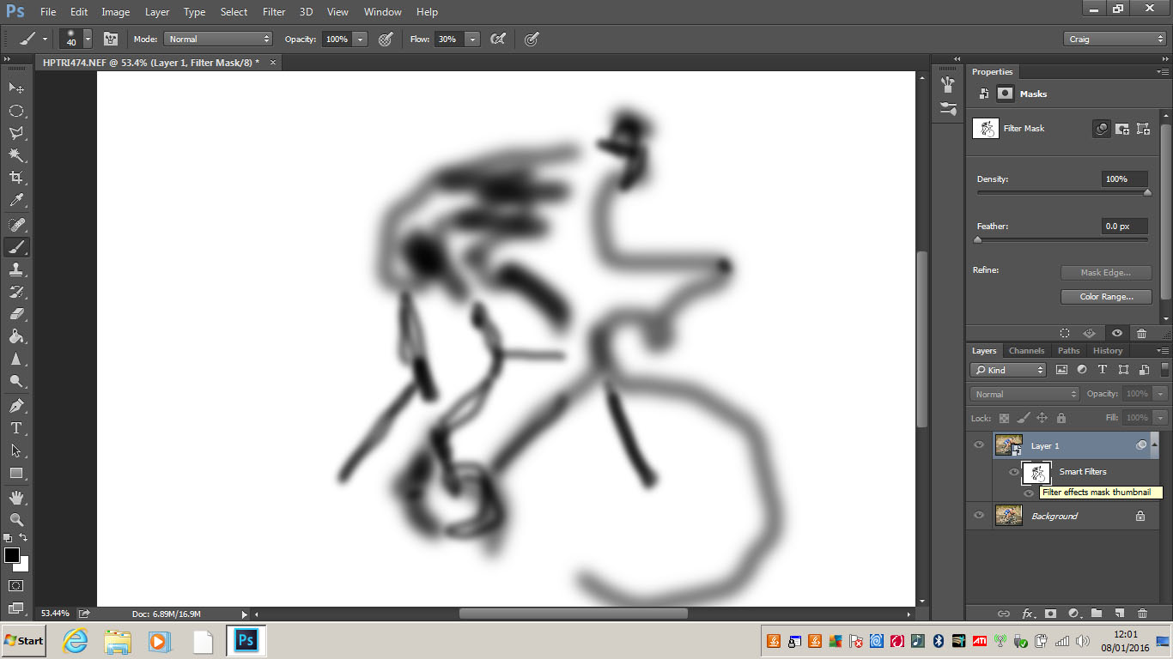
Now to make the wheels look like they are spinning. Double click on the Blur Galley (under the mask icon) in the layers palette to re-enter the blur gallery. This time select Spin Blur. Move the centre point over the wheel axle and move the hanles inwards to the shape of the wheel. Move the slider to get the right amount of spin. Here I used 16°.Click on the second wheel and do the same, then the drive cog. Click OK when done.
NB. The preview window will blur the bike frame, but as we have masked out the bike frame, when you click OK the mask will remove the blur from the spinning wheels where they cross the bike frame.
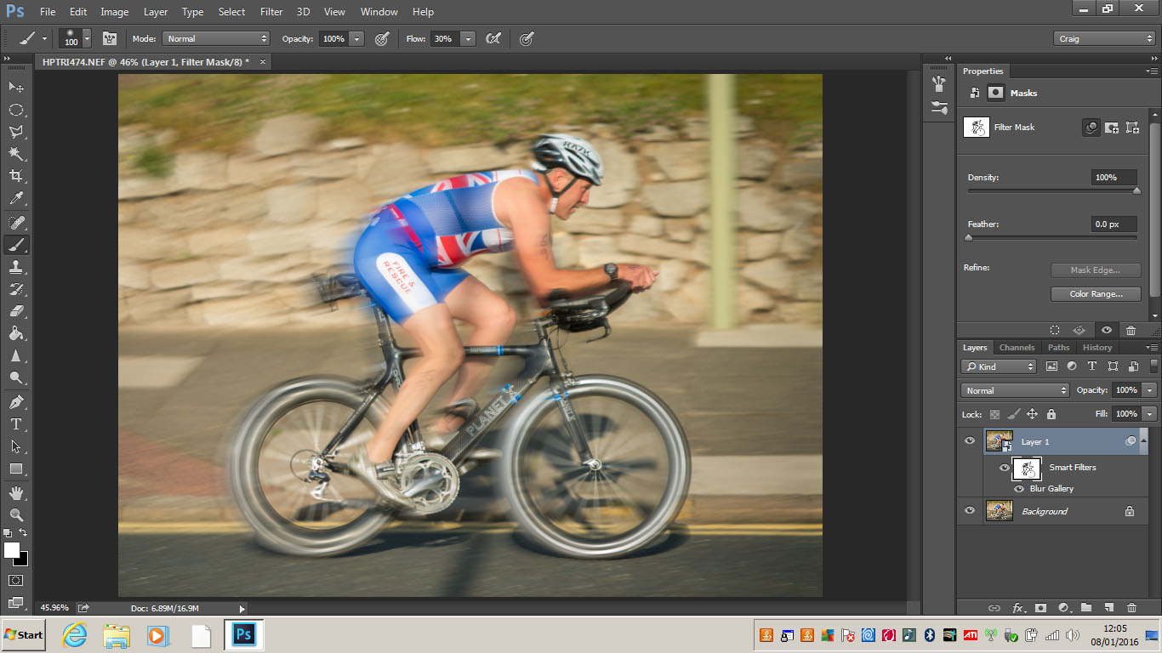
Done!

