Making a Window Effect Background
This little tutorial will show you how to make a boring studio backdrop look a bit more interesting and will show the following techniques.
- Making selections
- Content Aware Scale
- Step and Repeat transformations
- Smart objects and filters
- Masks
- Using the Blur Galleries
First of all, we need a picture. This image of Jade was taken last year in North Corner Studios, Hebburn.
To isolate the model from the backdrop it is sometimes easier to select the backdrop and then invert. Take the magic wand tool, click on Contiguous and set the tolerance to 20. Click on the background. If too much of the model has been selected then lower the tolerance and try again. Shift+click areas to add to the selection. Switch to the quick selection tool and hold down Alt to deselect the parts of the selection that have gone too far.
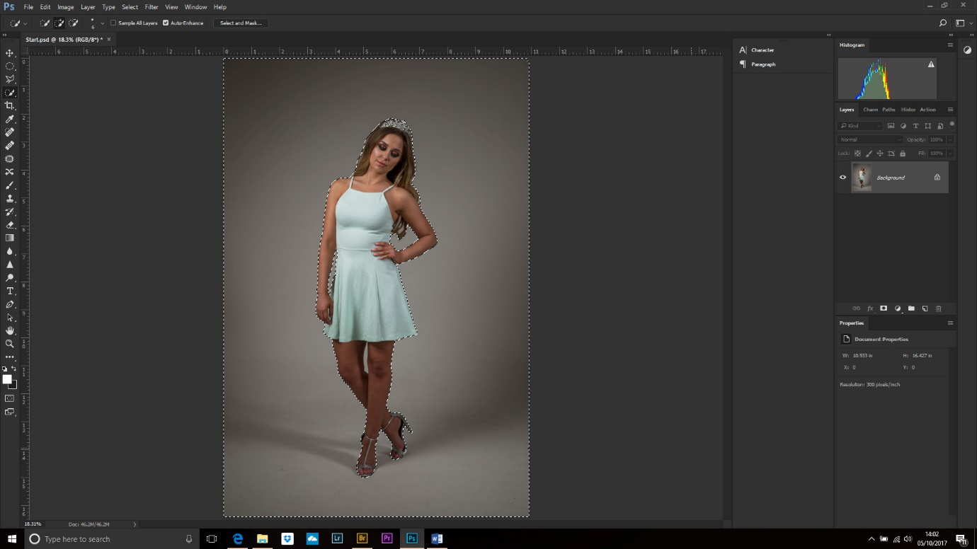
Click on Select and Mask to enter the dialogue box.
Use the Refine edge tool (2nd tool down) to paint back some of the hair.
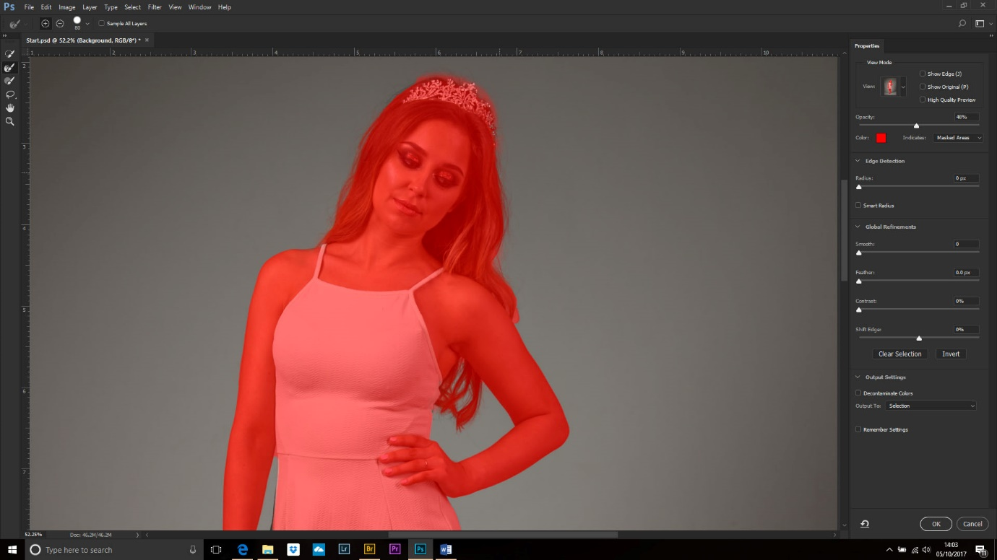
Click on the Invert button then Output: New layer with layer mask. Okay
Click back on the background layer.
We want to make this image wider so we are going to use the crop tool. Drag out to the left to increase your canvas size.
Get your rectangular marquee tool and select an area that includes the backdrop, but not the model or any of the transparent part.
Edit>Content Aware Scale and drag the left middle handle until the empty canvas has been covered. NB. You could sort any shadows at this point, if you wish.
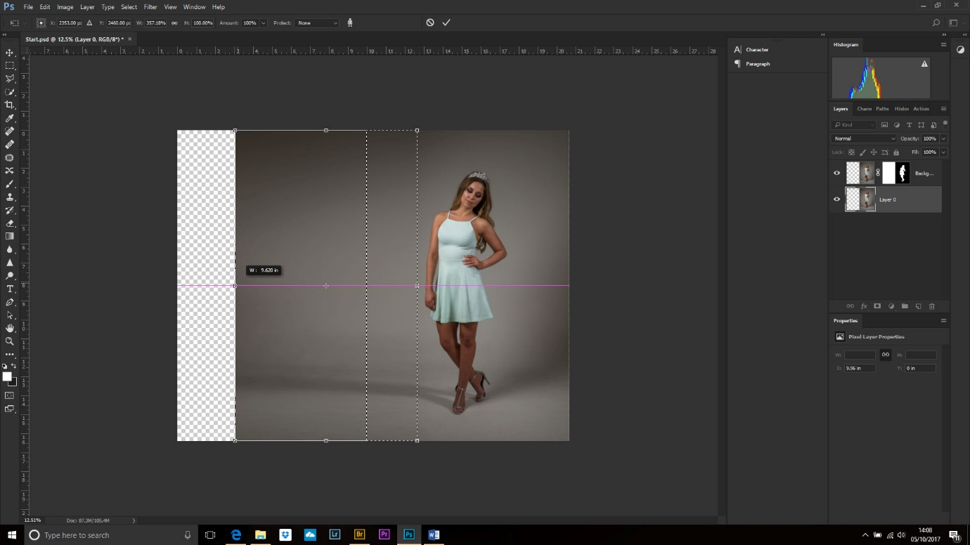

Make a new blank layer above the background layer.
Select your rectangular marquee tool and make a box. Edit>Fill and choose white (Shortcut: Alt+Backspace if your foreground colour is white, Cntl+backspace if your background swatch is set to white).
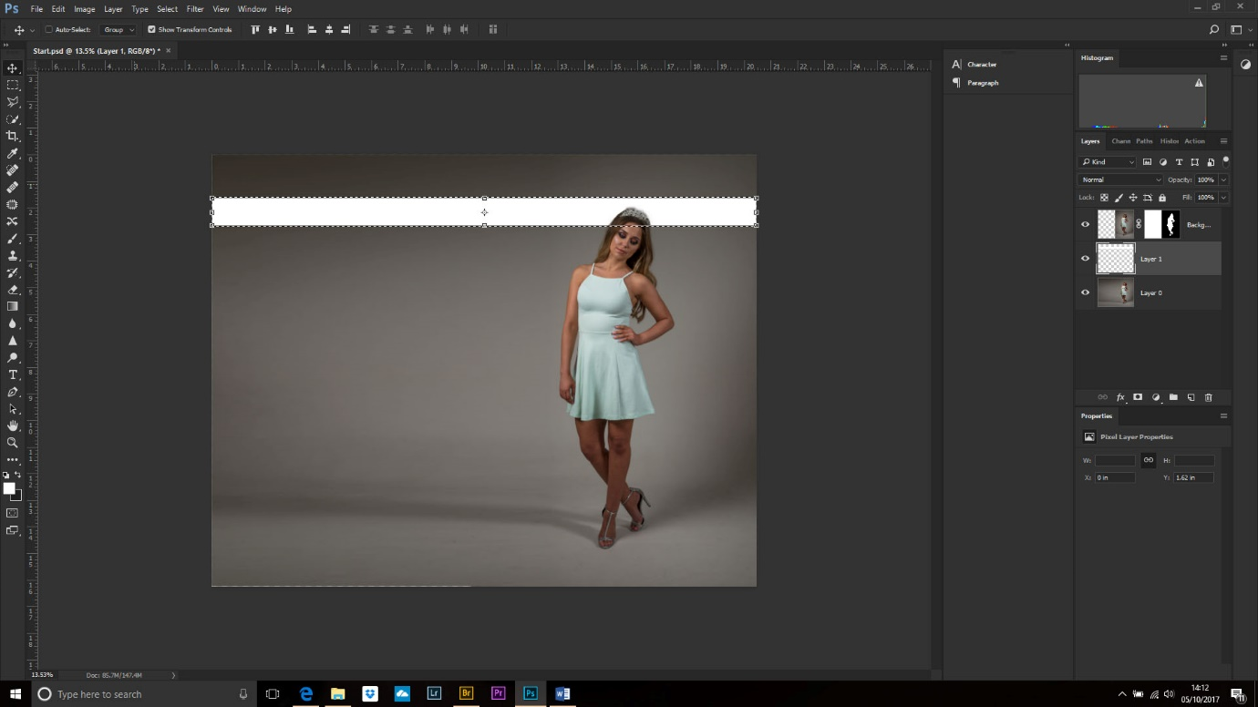
Now we could copy and paste this white rectangle several more times to create the blinds effect, but it is difficult to get them perfectly aligned. A quicker and more accurate method uses ‘Step and Repeat’ transformations.
With the white rectangle layer selected press Cntl+Alt+T (CAT if you need a mnemonic to help you remember). With the move tool click inside the rectangle and drag it to its new position. Press ok.
Hold down Cntl+Alt+T+Shift (CATS) and the above action will be repeated. Do this several times to get the effect.
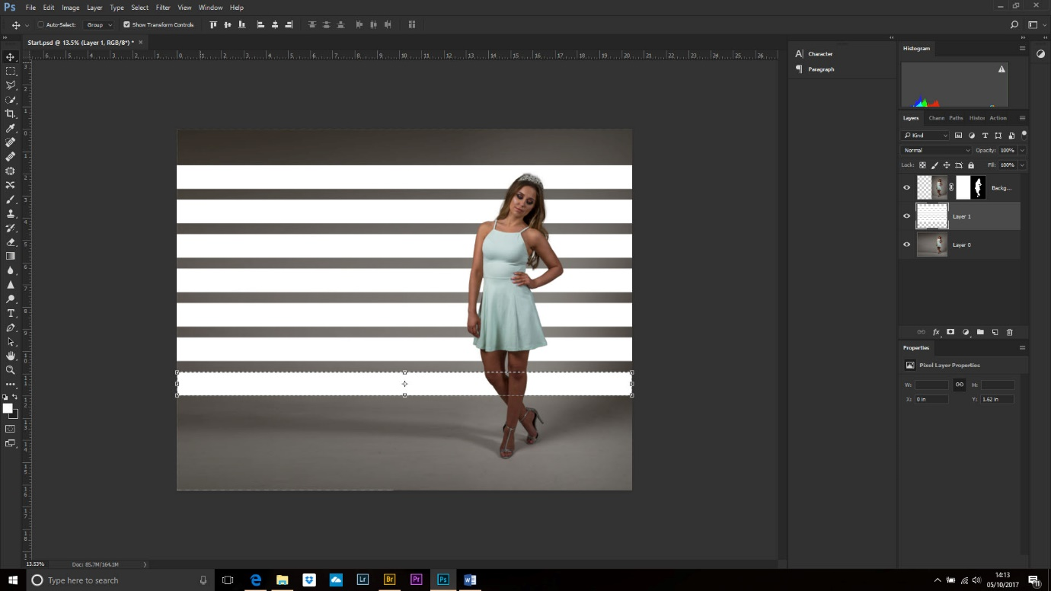
Now, to make the boxes look more realistic change the Blending Mode to Overlay.
Add a bit of distortion using Edit>Transform>Distort and move the corner handles while holding down Shift to keep the transformation straight.
We want to add a blur but we need to be able to control this. Right click on the layer and choose Convert to Smart Object.
Filter>Blur Gallery>Field blur and move the slider to add blur.
Filter>Blur Gallery>Tilt and shift blur. Move the position of the start to the far left (click and drag on the circle) then change the orientation of the blur from horizontal to vertical using the double-headed arrows.
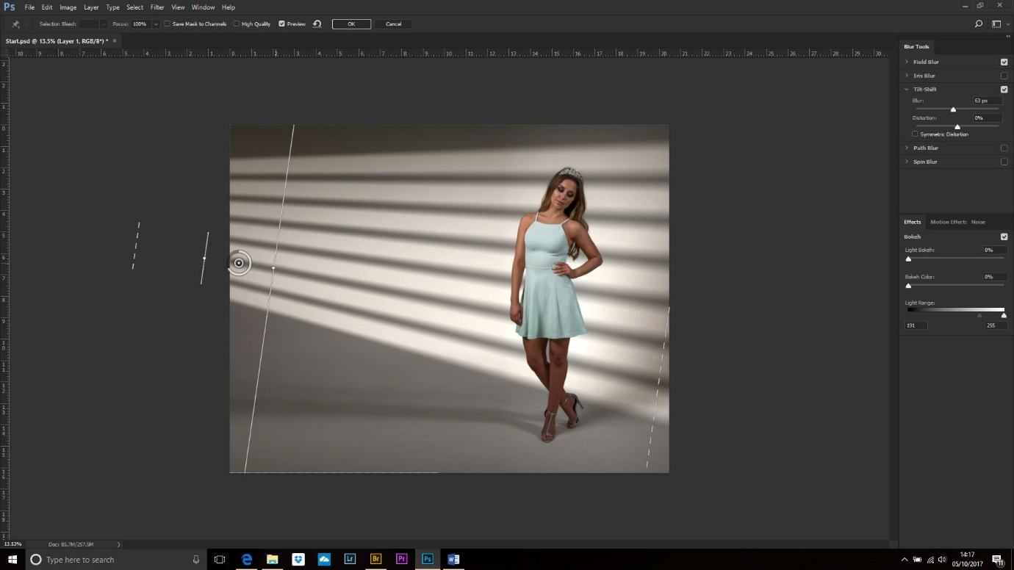
Drag the end of the blur to the right and move the slider to get the right effect.
Click inside the mask box and use a Black to White gradient to fade the blur.
I added a mask to the layer and used a gradient on about 40% opacity black to white to fade the lines a little.
Now a little trick. If we want to add more blur then doing another gradient on the smart object mask will replace it – which we don’t want. To make another new mask make sure the rectangles layer is selected and Cntl+G to form a new group. Add a layer mask to this and use the black to transparent gradient to modify the corners.
To make vertical lines choose a small, medium soft brush at 100% opacity. Click on the mask and then click once above the window effect. Hold down Shift and click below the window to get a perfectly straight line.
Make the brush slightly larger and do the same further to the right.
To help blend the tones add a Photo filter adjustment layer or Color Lookup layer right at the top.
Done!
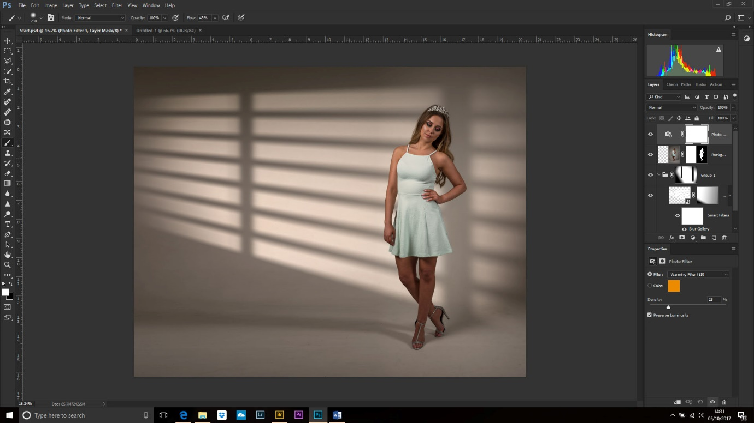
NB. I would now fix the shadow, but that’s for another lesson!

